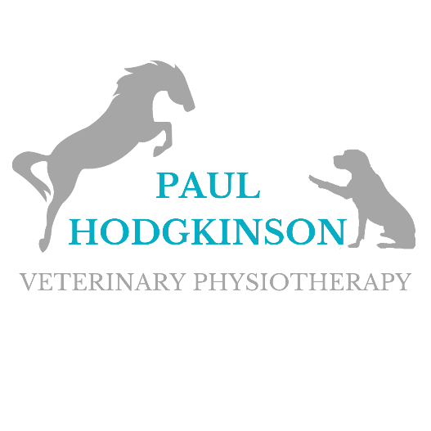

Booking Terms and Conditions

General
- All animals will only be seen for physiotherapy care in accordance with the Veterinary Surgeon’s Act 1966 and exemptions order 2015. Any physiotherapy assessment and/or treatment of your animal(s) may be discussed with your veterinary surgeon as required, and Paul Hodgkinson Veterinary Physiotherapy may refer a animal back to their veterinary surgeon for further investigation if deemed necessary at any stage.
- Paul Hodgkinson Veterinary Physiotherapy reserves the right to refuse treatment if it is deemed to be either inappropriate or unsafe (such circumstances might for example include the presence of undiagnosed lameness, infectious or contagious diseases, or other health or behavioural concerns).
- All animals need to be dry and brushed clean with visible mud removed for effective assessment and treatment to take place.

Payment
- Payment is required on the day by cash, or direct bank transfer, unless a credit agreement has specifically been made where the terms of payment will then be clearly stated on your invoice (existing customers in good standing may also be given 7 days grace for the completion of bank transfers at our discretion). These payment terms still apply where treatment might form part of an insurance claim. Receipts will be issued for you to later submit to your insurance company, but it is your responsibility to confirm with your insurers beforehand that your claim is being accepted by them and that any physiotherapy costs will be reimbursed to you.
- In the unfortunate event of any difficulties in paying an outstanding invoice amount, please contact us to discuss the matter in the first instance as soon as possible, so that a suitable repayment plan can be arranged. Please note that we reserve the right to pursue unpaid accounts in any appropriate manner, which may include the use of a debt collection service or civil proceedings. Any additional costs that might ultimately be incurred by Paul Hodgkinson Veterinary Physiotherapy in the process of having to recover outstanding fees will be added to the balance of your account along with standard rates of interest.
Cancellation Policy
- Cancellations, or postponements within 48hrs of the appointment will be charged at £35 for dogs and £50 for horses, increasing to 100% when made within 24hrs of the appointment or if the appointment is missed.
- Lateness of more than 20 minutes without prior notification will also be deemed as you have missed your appointment. It is understood that sometimes things do happen at short notice but please always try to notify us as early as possible of any changes because it helps to ensure that time is never wasted and that another animal may be able to benefit from your appointment space instead. Late payments will incur an additional fee of £5 per reminder. N.B. Following repeat cancellations, Paul Hodgkinson Veterinary Physiotherapy reserves the right to request full payment of treatment fees and any applicable cancellation charges in advance when re-booking.

I …………....…………………………………………… hereby agree to the Terms and Conditions, as set out above, by Paul Hodgkinson Veterinary Physiotherapy.

Signed ………………………………………………………. Date:.….../.…../ 20….….

Paul Hodgkinson Veterinary Physiotherapy
07979 818 668
Paulhodgkinson.vetphysio@gmail.com
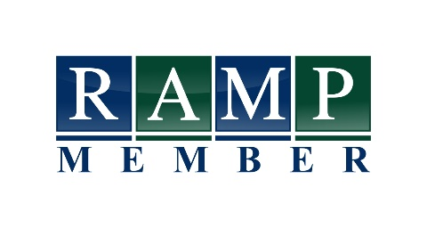
www.paulhodgkinson-vetphysio.co.uk

